**EXPNO:1 Configuration of Network Devices using Packet Tracer tools (Hub, Switch, Ethernet, Broadcast)**

**Output:**

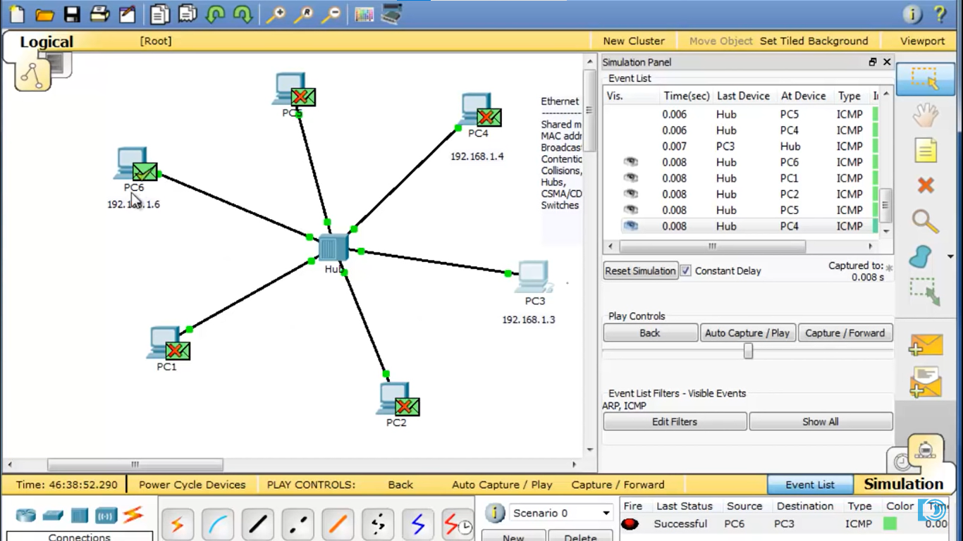

**EXPNO:2 Design and Configuration of Star Topologies using Packet Tracer.**

**Output:**

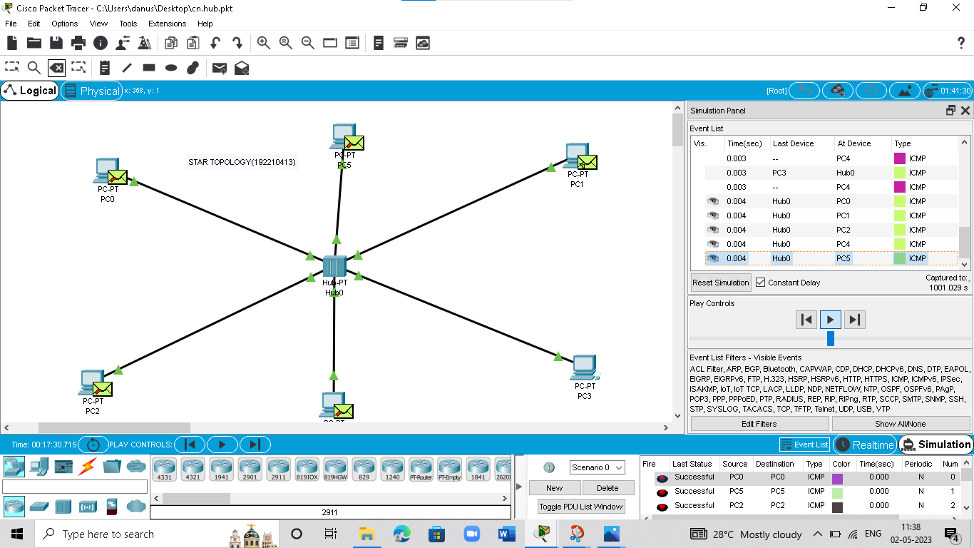

**EXPNO: 3 Design and Configuration of BUS Topologies using Packet Tracer.**

**Output:**

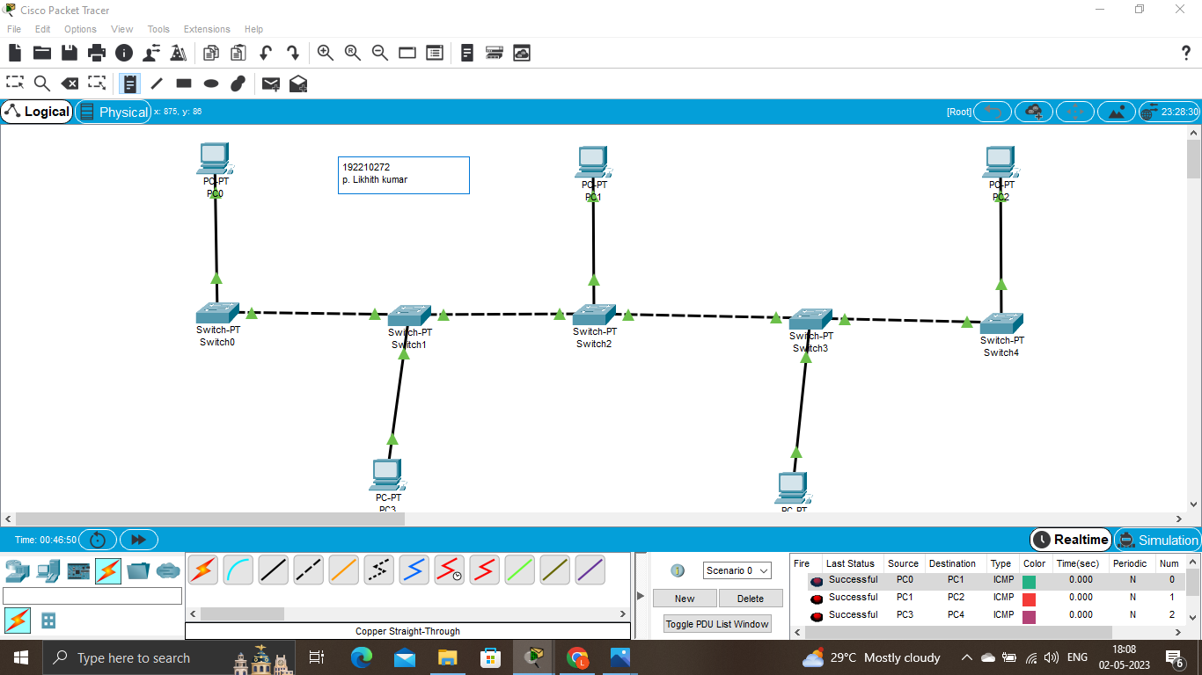

**EXPNO:4** **Design and Configuration of RING Topologies using Packet Tracer**

**Output:**

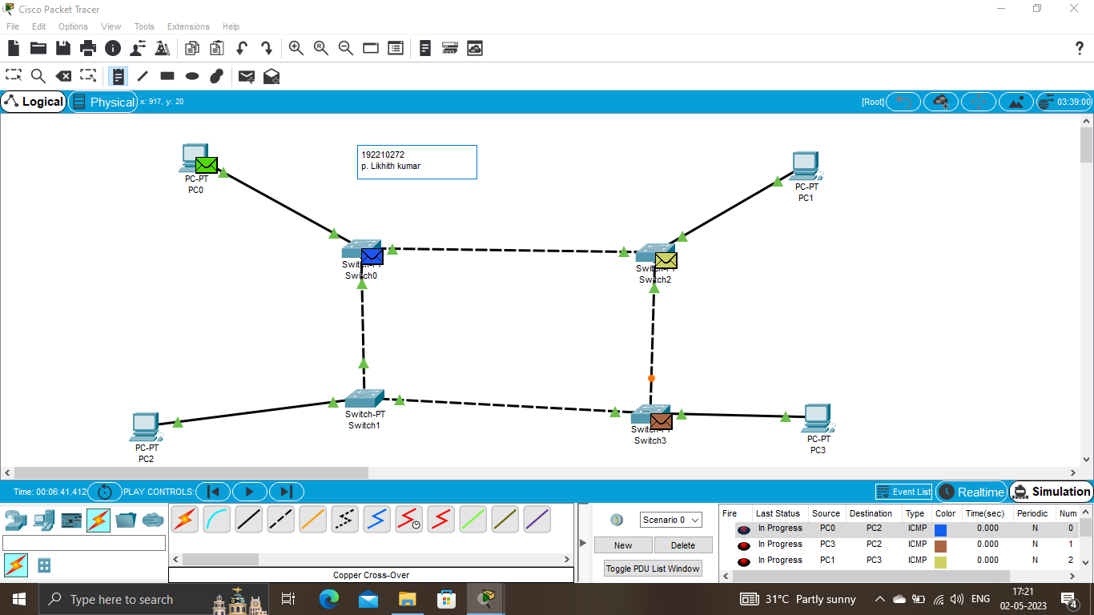

**EXPNO:5 Design and Configuration of Mesh Topologies using Packet Tracer**

**Output:**

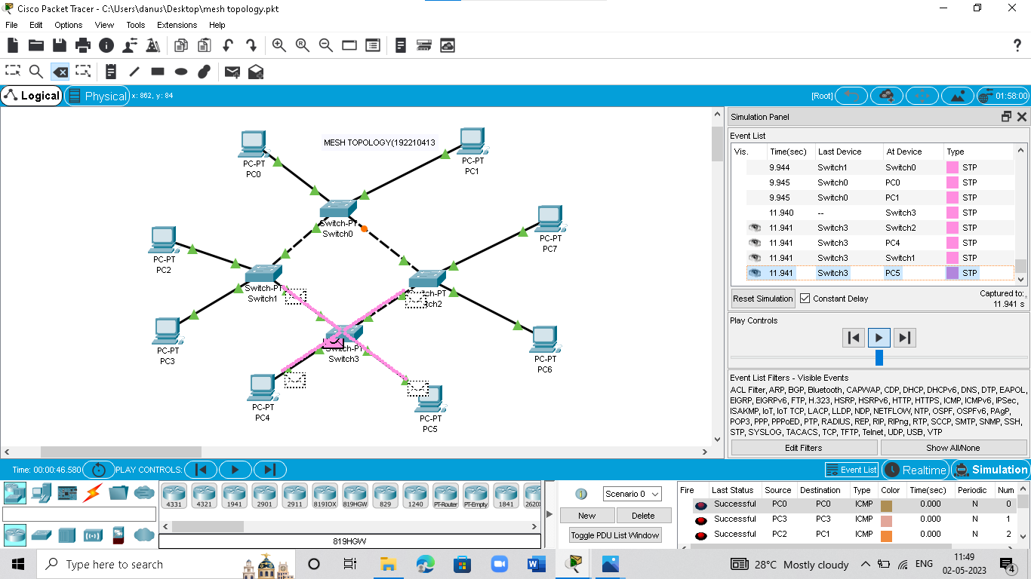

**EXPNO:6** **Design and Configuration of Tree Topologies using Packet Tracer.**

**Output:**

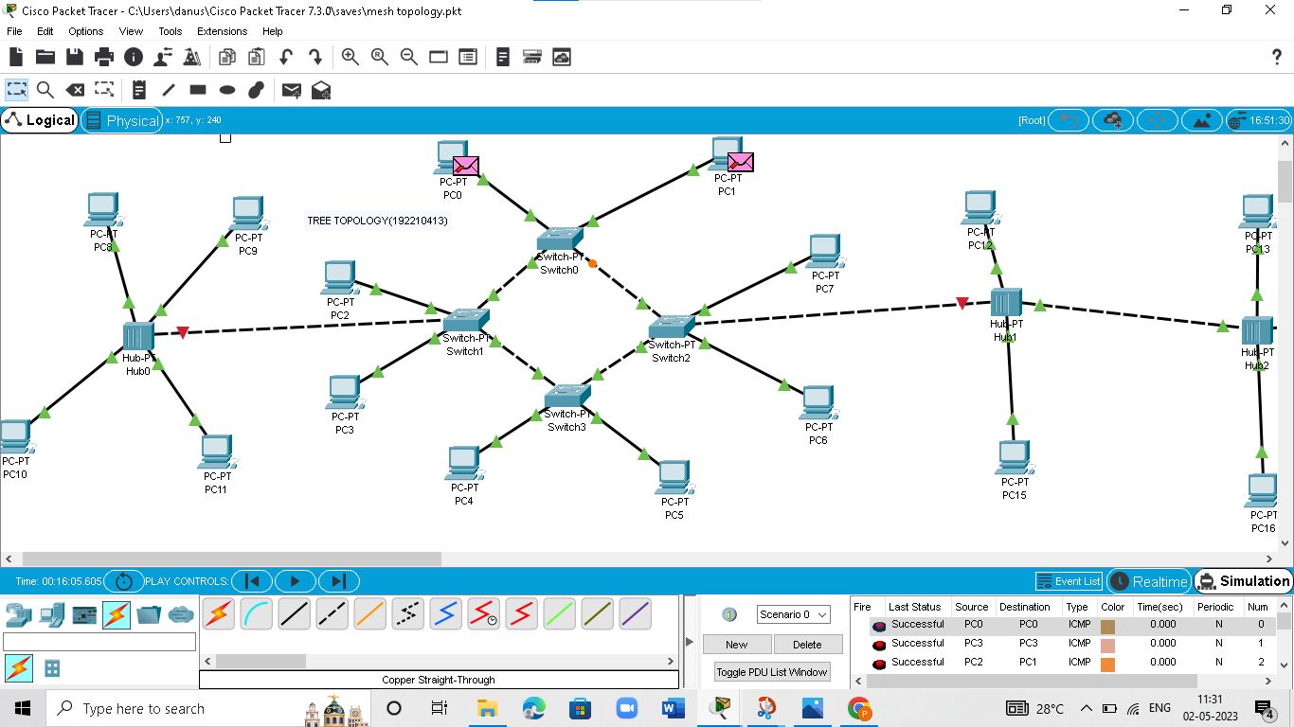

**EXPNO:7 Design and Configuration of Hybrid Topologies using Packet Tracer.**

**Output:**

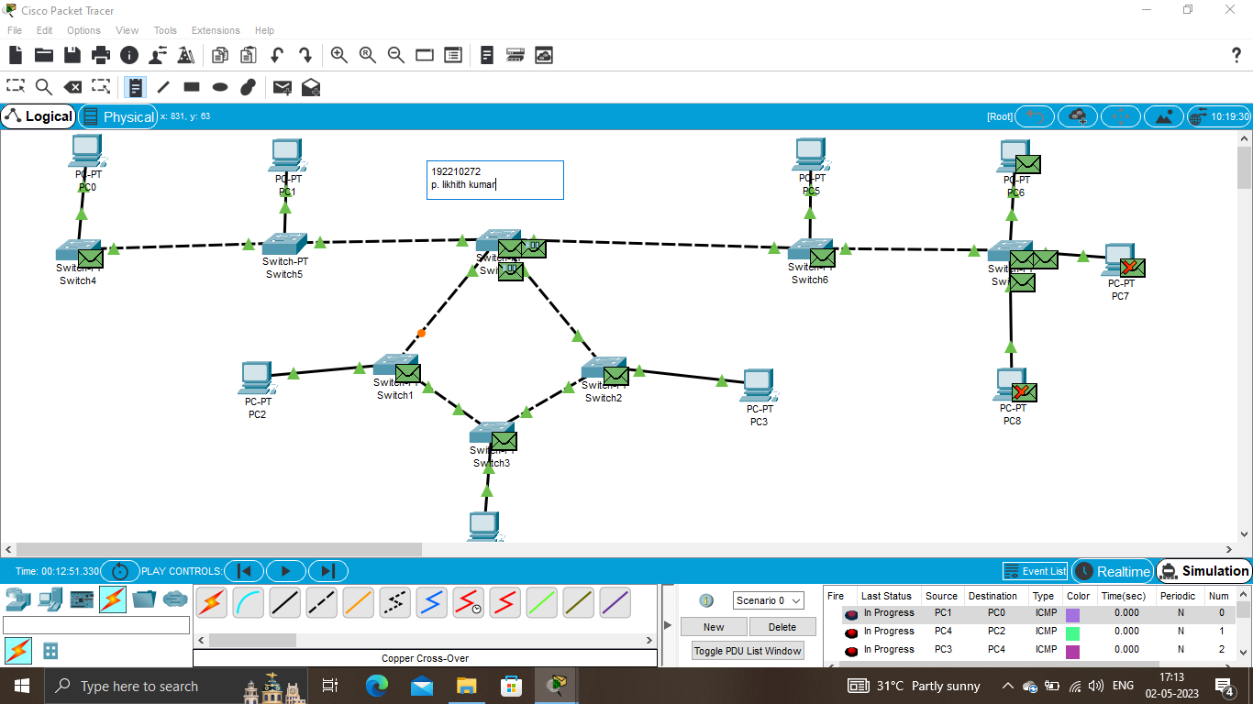

**EXPNO:8 Data Link Layer Traffic Simulation using Packet Tracer Analysis of ARP.**

**Output:**

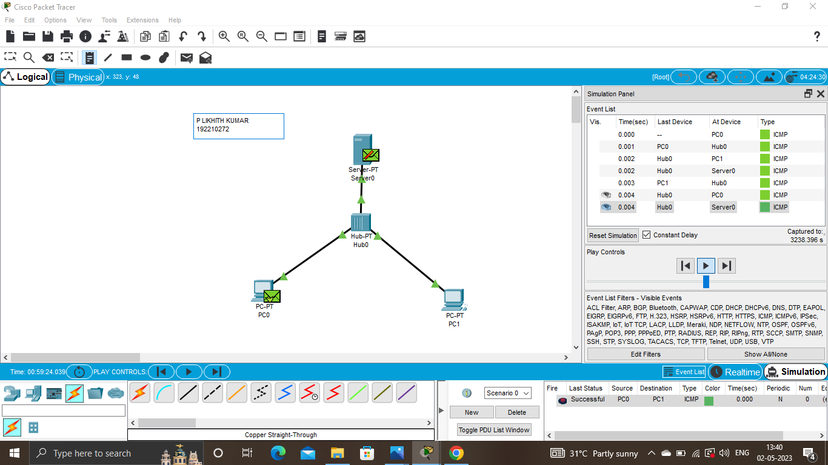

**EXPNO:9 Data Link Layer Traffic Simulation using Packet Tracer Analysis of CSMA/CD & CSMA/CA.**

**Output:**

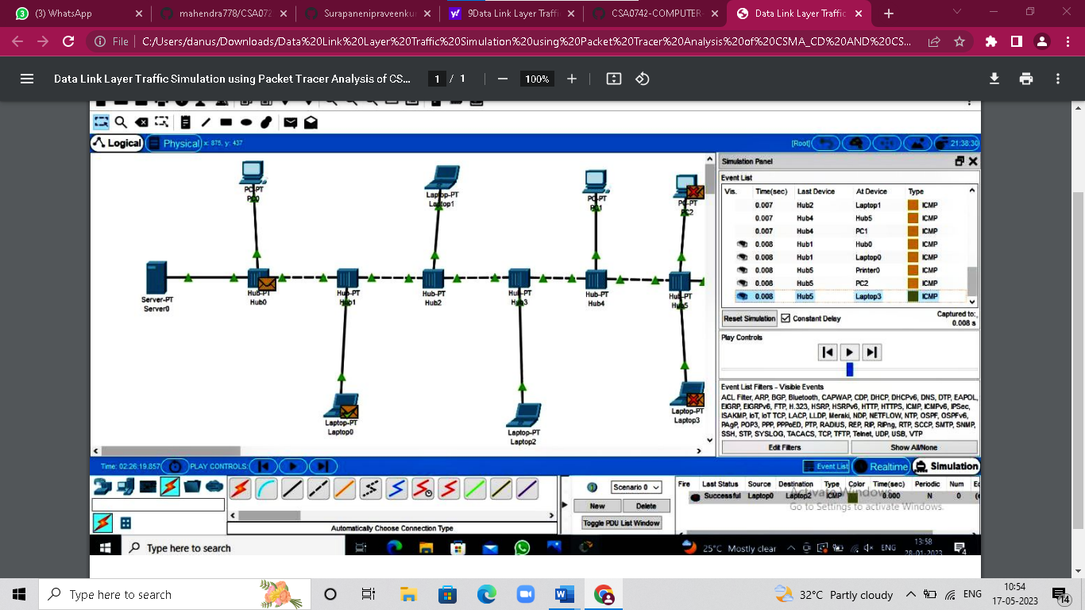

**EXPNO:10** **Making Computer Lab in Cisco Packet Tracer**

**Output:**

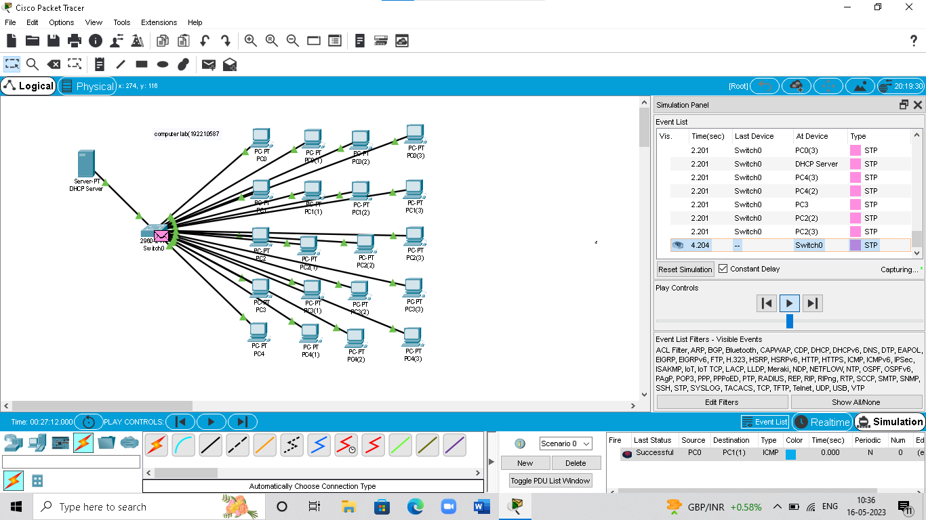

**EXPNO:11 Designing two different network with Static Routing techniques using Packet Tracer.**

**Output:**

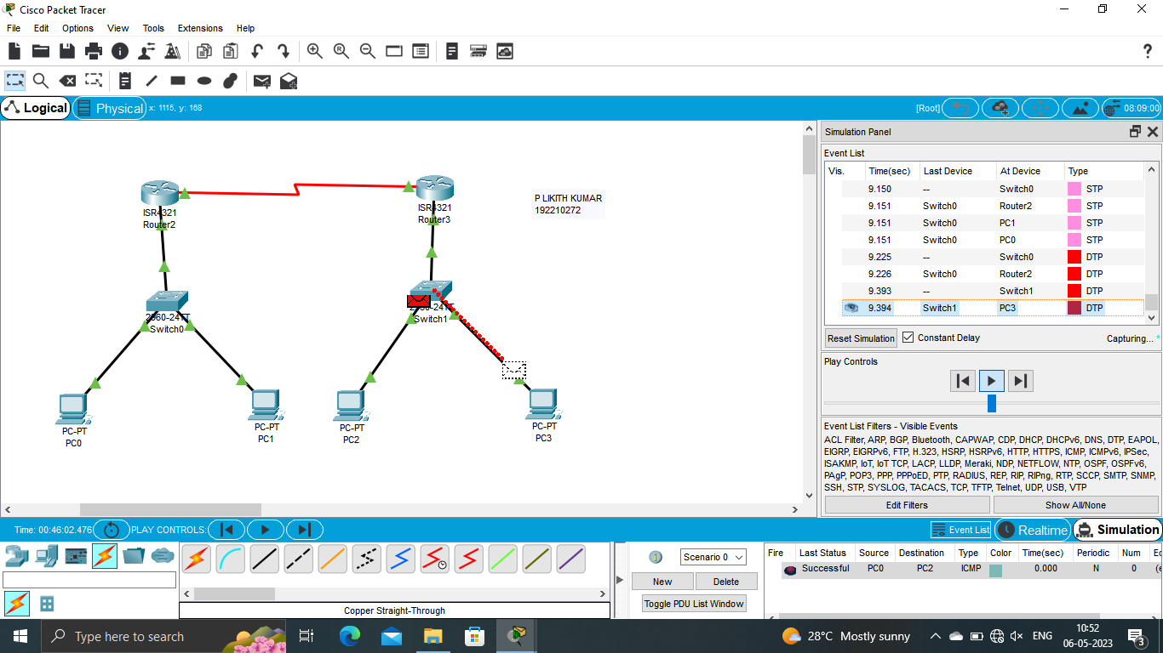

**EXPNO:12 Design the Functionalities and Exploration of TCP using Packet Tracer**

**Output:**

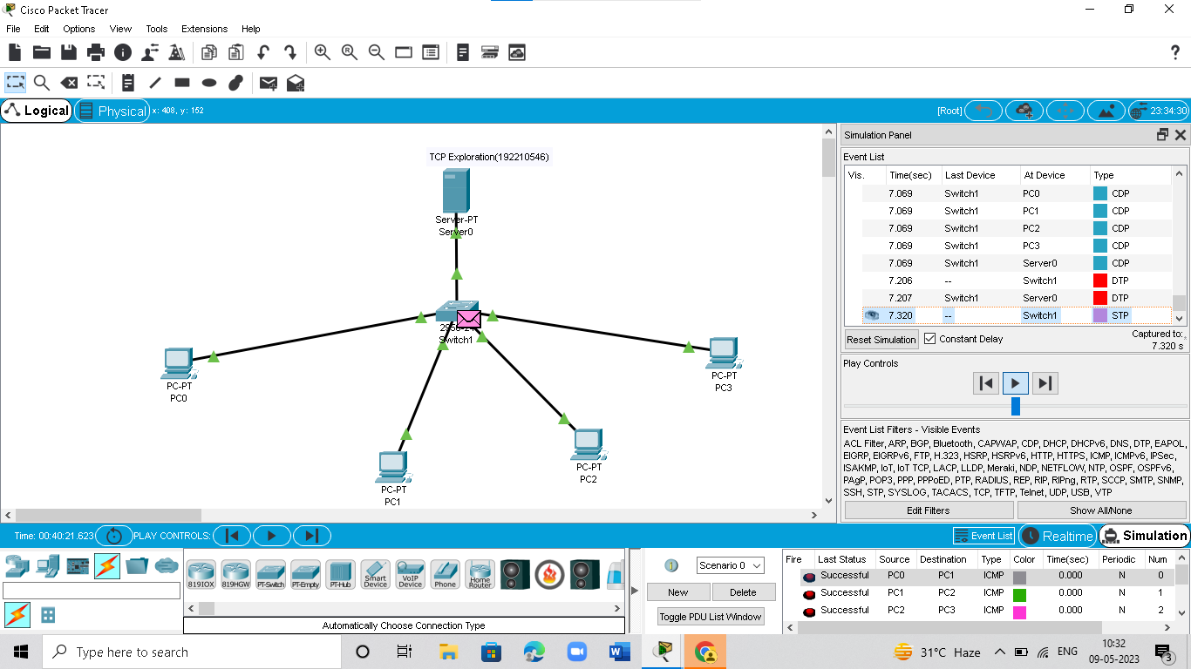

**EXPNO:13 Design the network model for Subnetting – Class C Addressing using Packet Tracer.**

**Output:**

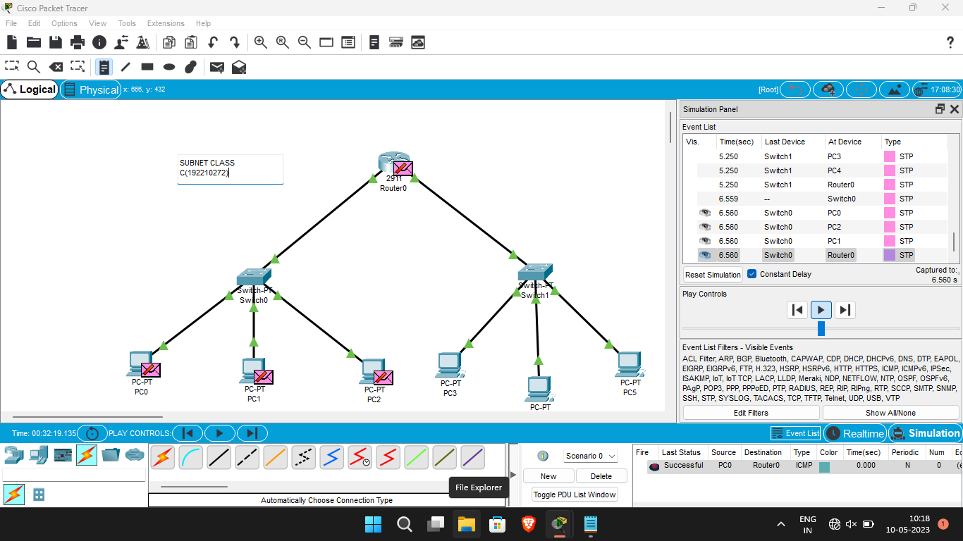

**EXPNO:14 Simulating X, Y, Z Company Network Design and simulate using Packet Tracer.**

**Output:**

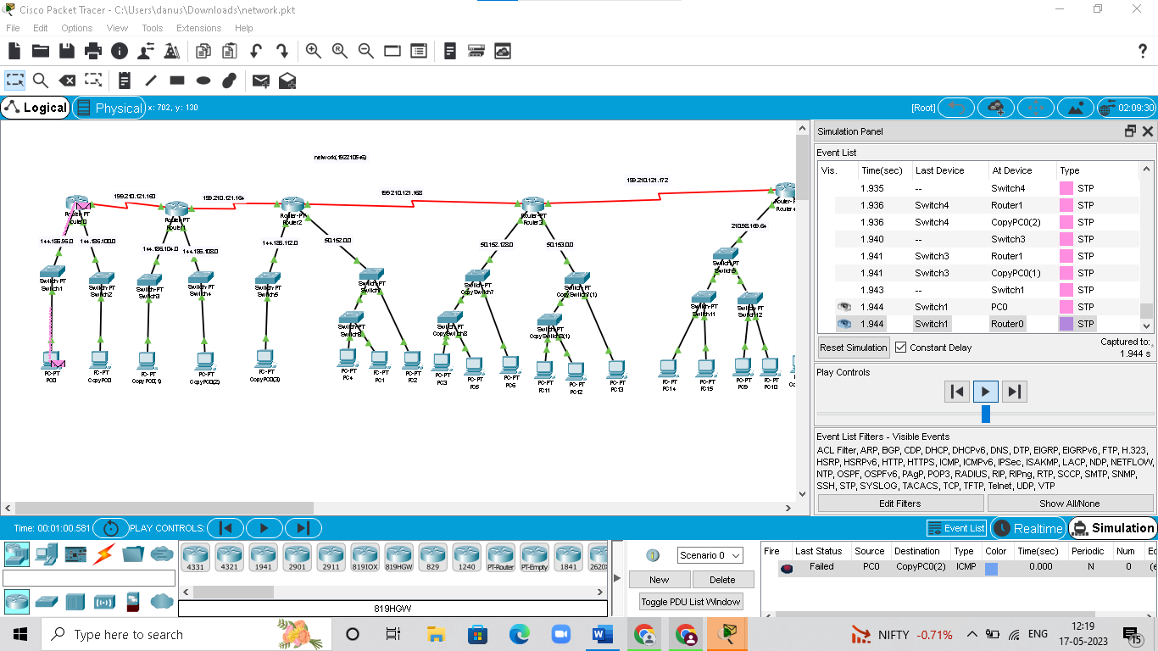

**EXPNO:15 Configuration of DHCP (dynamic host configuration protocol) in packet Tracer.**

**Output:**

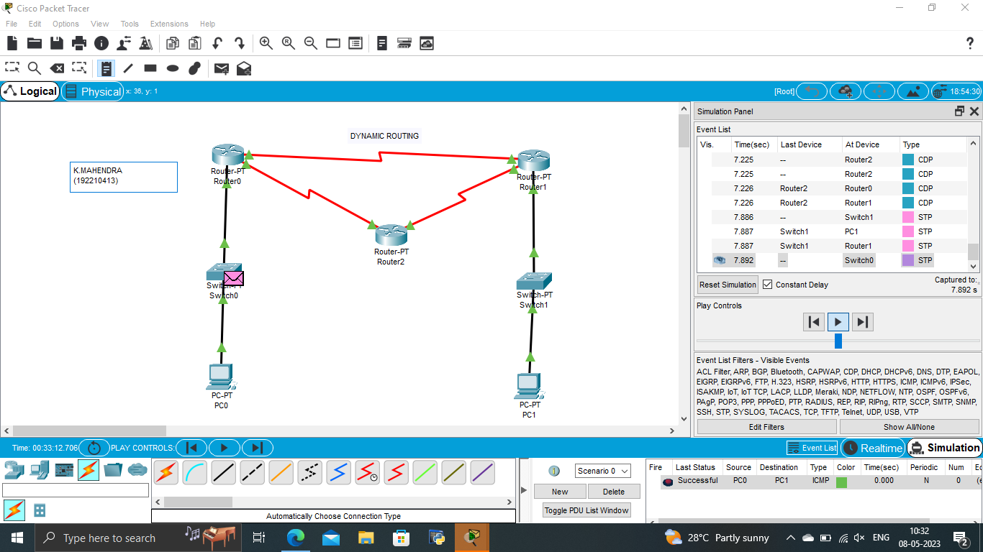

**EXPNO:16 Configuration of firewall in packet tracer.**

**Output:**

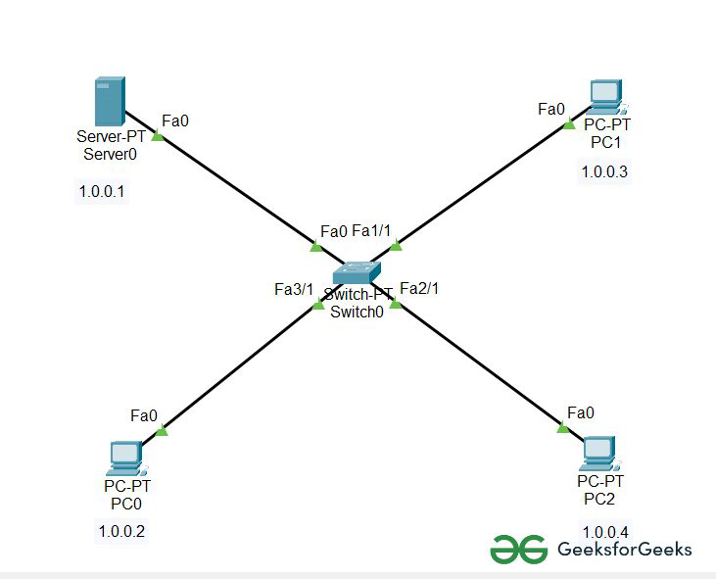

**EXPNO:17 Make a Computer Lab to transfer a message from one node to another to design and simulate using Cisco Packet Tracer.**

**Output:**

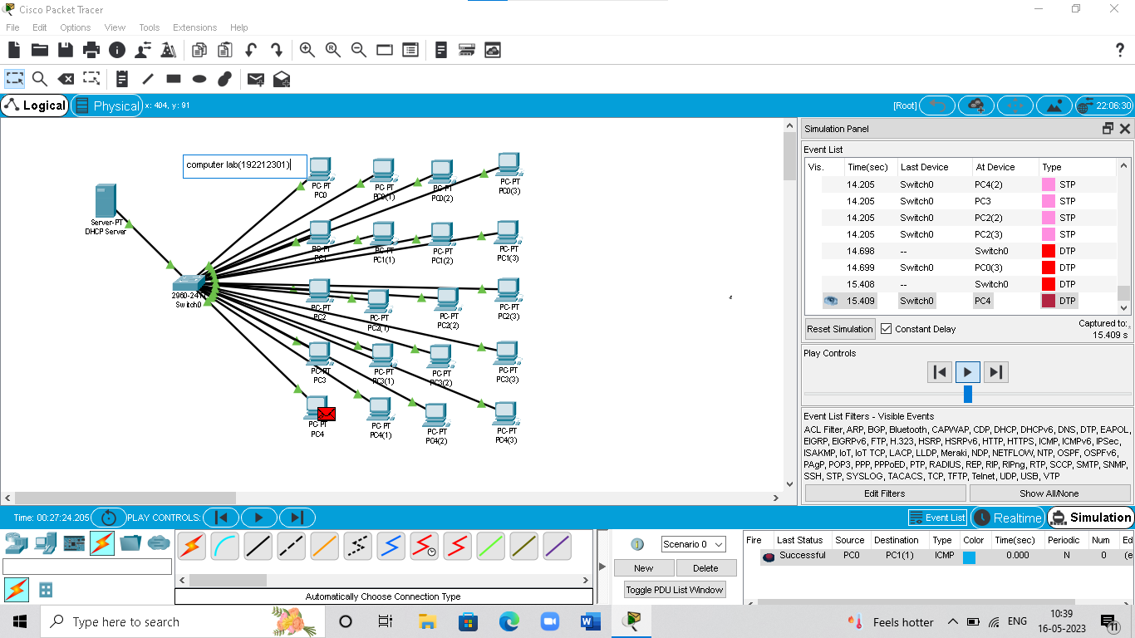

**EXPNO:18 Simulate a Multimedia Network in Cisco Packet Tracer.**

**Output:**

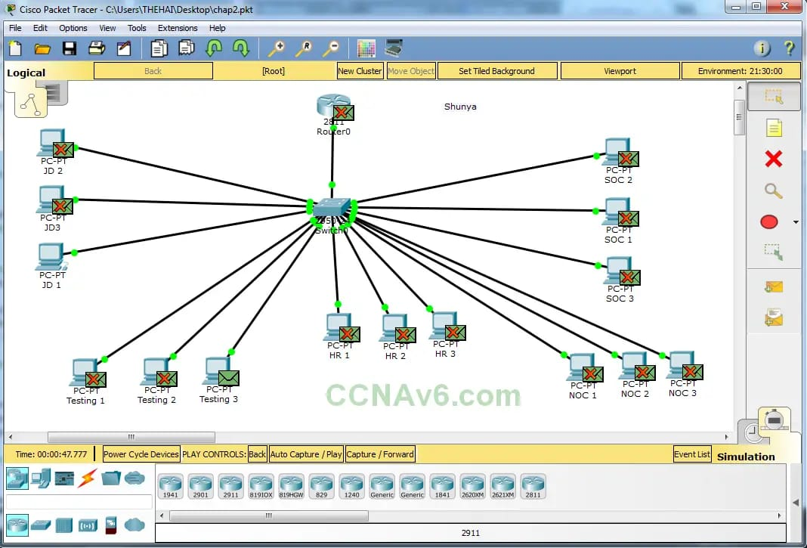

**EXPNO:19 IoT based smart home applications.**

**Output:**

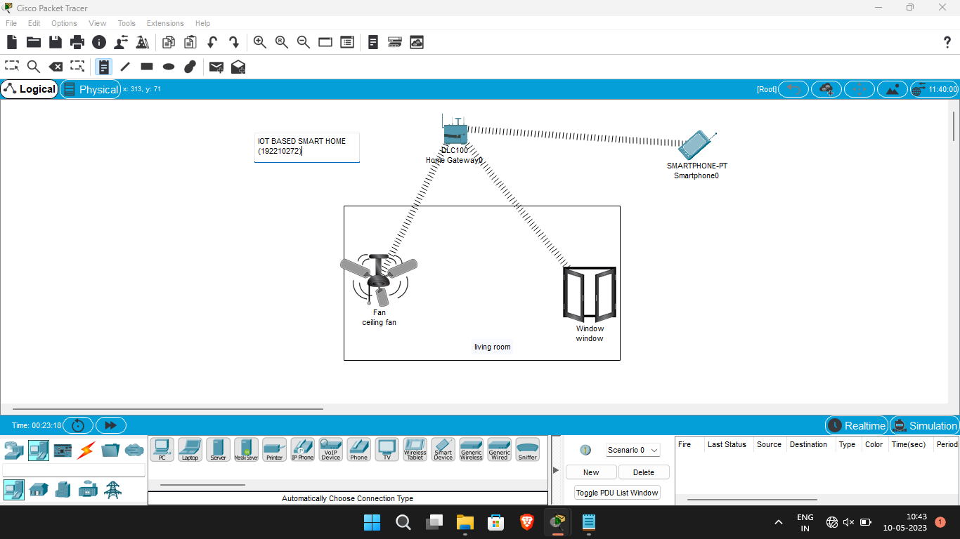

**EXPNO:20 Implementation of IoT based smart gardening.**

**Output:**

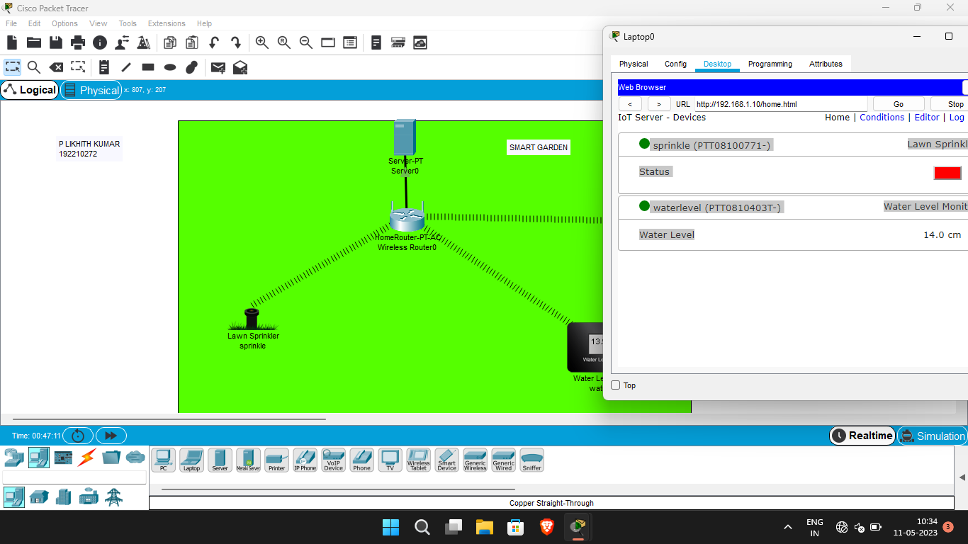

**EXPNO:21 Implementation of IoT devices in networking.**

**Output:**

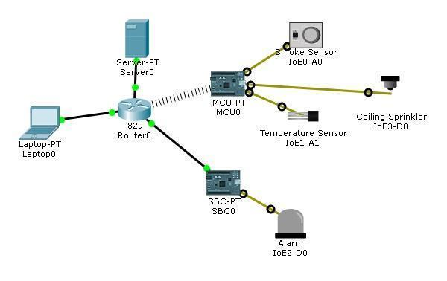

**EXPNO:22 IoT based AAA Local and Server based authentication configuration.**

**Output:**

